**GreenSock Animation Platform (GSAP)**

**Introduction**

GSAP (GreenSock Animation Platform) is a robust JavaScript library used for creating high-performance animations. It provides a suite of tools and features to create complex animations with ease, offering precision and flexibility.

**Installation**

**Via CDN**

Include GSAP via a CDN in your HTML file:

<script src="https://cdnjs.cloudflare.com/ajax/libs/gsap/3.11.0/gsap.min.js"></script>

**Via npm/yarn**

npm install gsap

# or

yarn add gsap

**Basic Usage**

To create a simple animation using GSAP, you can use the **gsap.to** method:

**gsap.to(".element", { duration: 1, x: 100 });**

**Core Methods**

**GSAP offers several core methods to create and control animations:**

* **gsap.to(targets, vars): Animates the target elements to the specified properties.**
* **gsap.from(targets, vars): Animates the target elements from the specified properties.**
* **gsap.fromTo(targets, fromVars, toVars): Animates the target elements from specific properties to another set of properties.**
* 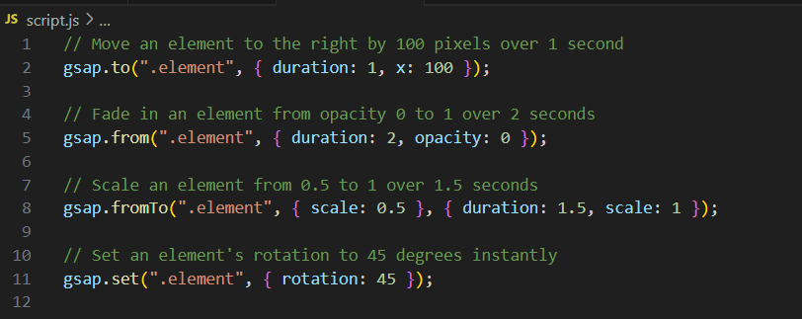

**Timelines**

**Timelines in GSAP allow for more complex sequencing and control of multiple animations.**

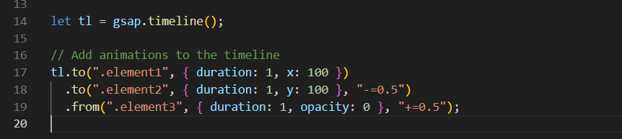

**Plugins**

GSAP (GreenSock Animation Platform) offers a variety of plugins that extend its capabilities, making it easier to create complex animations and interactions. Here's an overview of some of the most popular GSAP plugins:

**Easing:**

**Easing is the primary way to change the timing of your tweens.** Simply changing the ease can adjust the entire feel and personality of your animation. There are infinite eases that you can use in GSAP so we created the visualizer below to help you choose exactly the type of easing that you need.

**ScrollTrigger**

**Purpose:** Animates elements based on the user's scroll position.

**Features:**

* Trigger animations when elements enter the viewport.
* Pin elements in place while the user scrolls.
* Create scroll-based animations and effects.

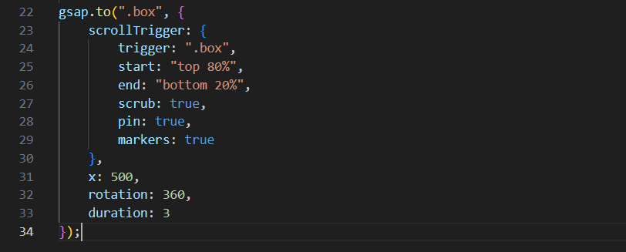

**ScrollTrigger Properties:**

**trigger:** The element that triggers the animation when it enters the viewport.

**start**: Defines when the animation should start relative to the viewport and the trigger element.

* Format: **"trigger point viewport point"**
* Default: **"top bottom"**

**end**: Defines when the animation should end.

* Format: Same as **start**.
* Default: **"bottom top"**

**scrub**: Links the progress of the animation to the scrollbar, creating a smoother animation effect.

* Accepts **true** or a duration (in seconds).

**markers**: Displays visual markers for debugging the start and end points of the trigger.

**pin**: Pins an element in place while the scroll position is between the **start** and **end** points.

* Accepts **true** or an element.

**pinSpacing**: Controls whether the pinned element creates space in the layout.

* Accepts **true**, **false**, or a string (**"margin"**, **"padding"**, **"none"**).

**toggleClass**: Adds/removes a class to/from an element when the scroll position reaches the start/end points.

* Format: **{targets: element, className: string}**

**animation**: Links a GSAP animation to the ScrollTrigger, making the animation play when the trigger is activated.

**onEnter**: A callback function that is called when the trigger element enters the viewport.

**onLeave**: A callback function that is called when the trigger element leaves the viewport.

**onEnterBack**: A callback function that is called when the trigger element re-enters the viewport from the bottom.

**onLeaveBack**: A callback function that is called when the trigger element leaves the viewport from the top.

**scroller**: Specifies the element that should be used for scrolling (useful for custom scroll containers).

**horizontal**: Indicates whether the ScrollTrigger should track horizontal scrolling instead of vertical.

**containerAnimation**: Allows ScrollTrigger to be used inside a container that is being animated by GSAP.

**Draggable**

**Purpose**: Enables dragging functionality for elements.

**Features**:

* Make any element draggable.
* Constrain dragging to certain bounds or axis.
* Throwing and inertia support.

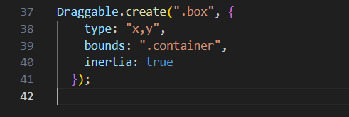

**MotionPathPlugin**

**Purpose**: Animates elements along a specified path.

**Features**:

* Animate elements along SVG paths or custom bezier curves.
* Precise control over path progression and orientation.

